Calculate the Area and Perimeter of a Rectangle

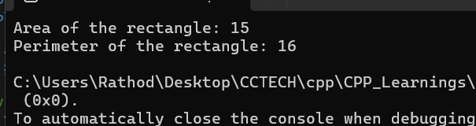

**Learning Outcomes**

1. **Understanding Constants**: You learned how to use constants in C++ to prevent modification of values that should remain unchanged throughout the program. This promotes better code maintainability and clarity.
2. **Class Design**: By implementing a class with constant member variables, you practiced encapsulating data and methods, which is a fundamental principle of object-oriented programming.